27th May

Create a directory called ""my_folder"", navigate into it

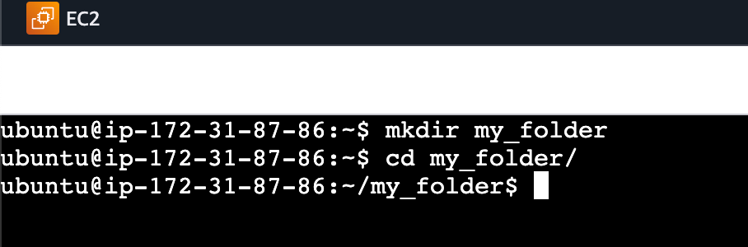

create a file named ""my_file.txt"" with some text

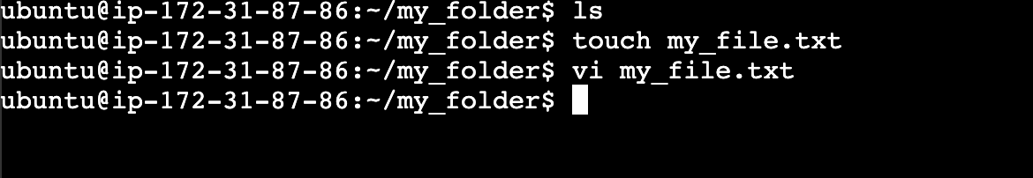

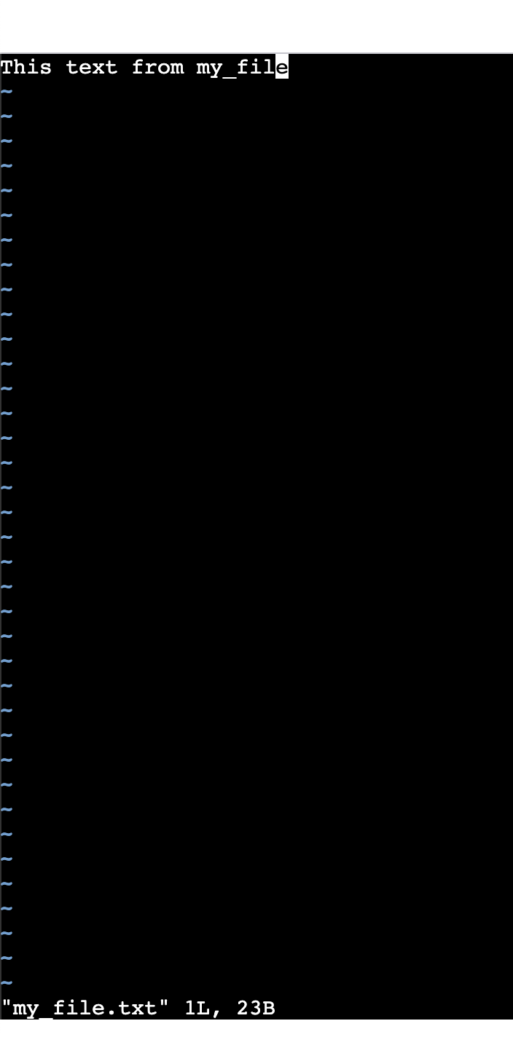

Then, create another file named ""another_file.txt"" with some text

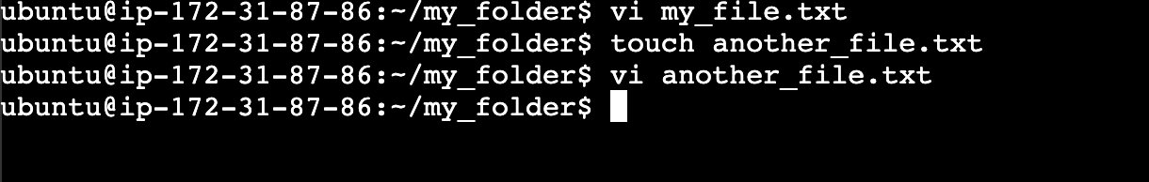

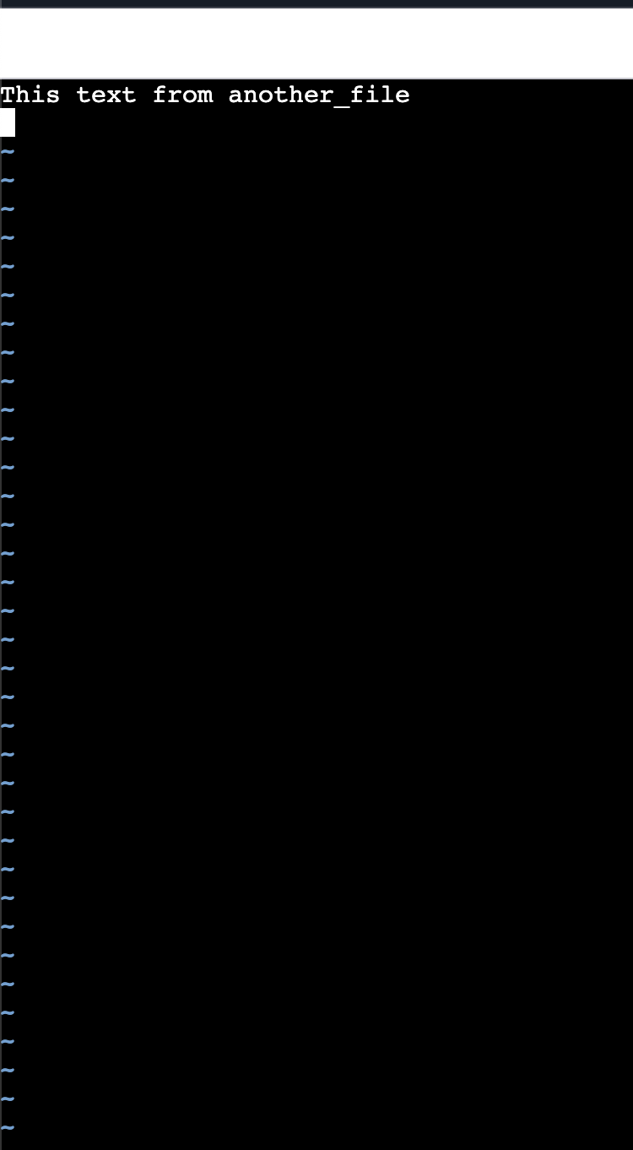

Concatenate the content of ""another_file.txt"" to ""my_file.txt""

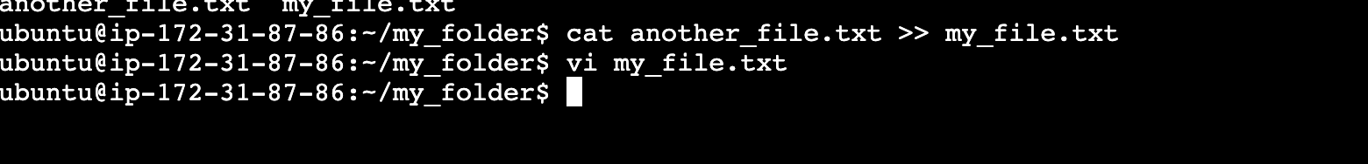

display the updated content.

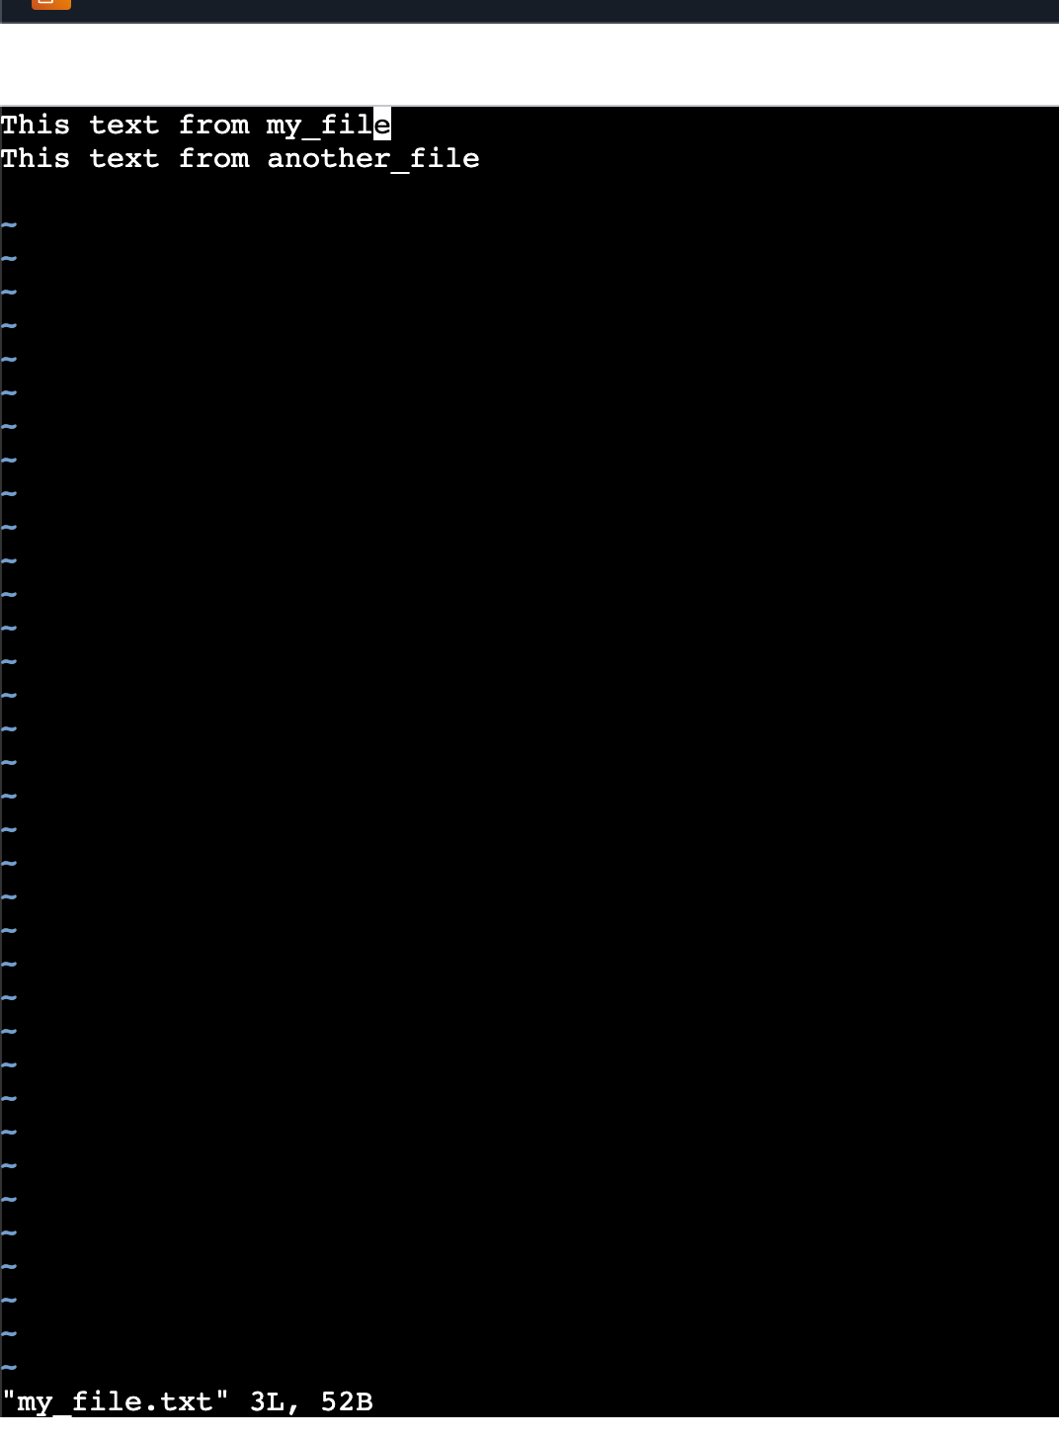

‘

Finally, list all files and directories in the current directory.

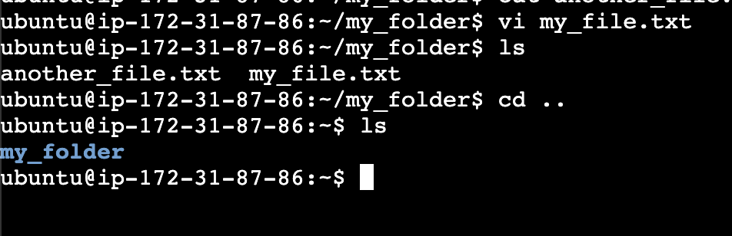

Create 20 files with .txt extensions

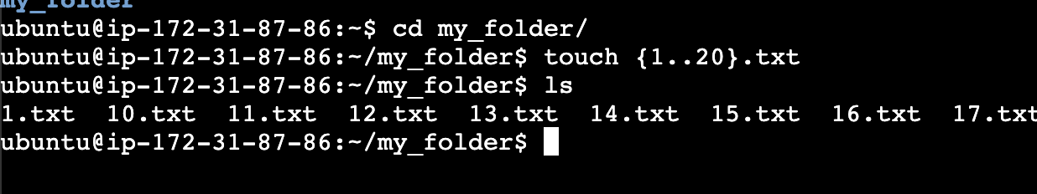

rename the first 5 files to .yml extension



Print the latest created top 5 files among the total no of files".

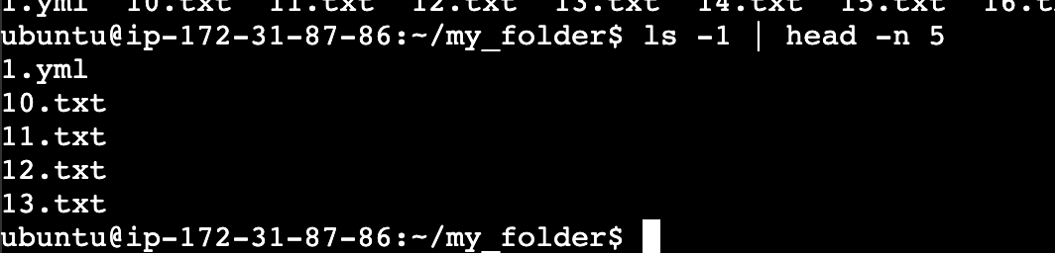

Shell (AWS, Gitbash, WSL, Vbox)

AWS

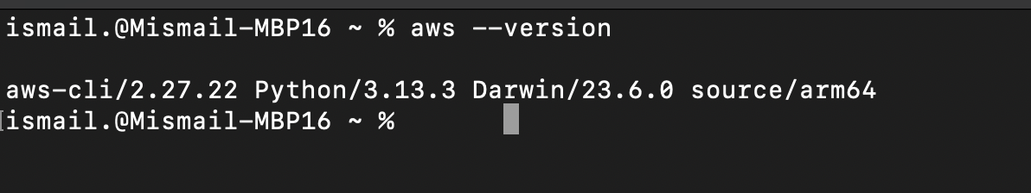

Gitbash

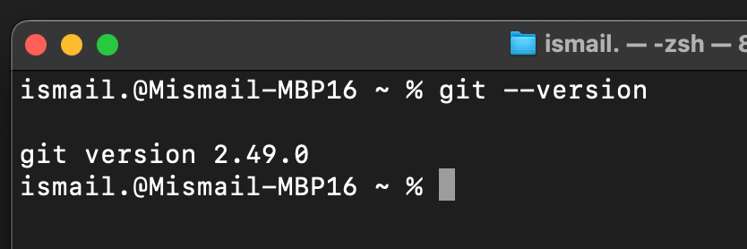

Vbox

virtualbox --version was opening the app 👀

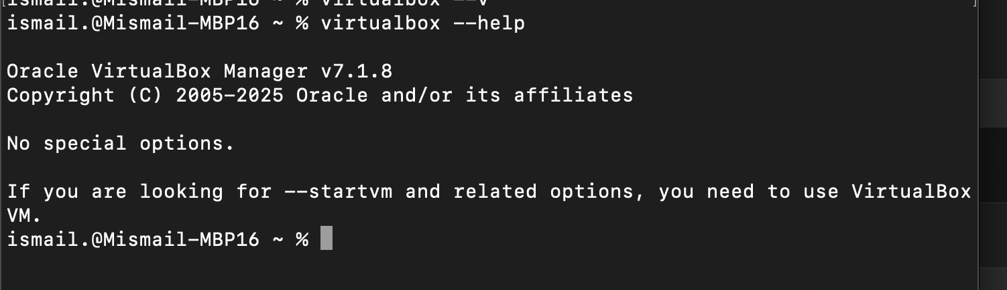

Github

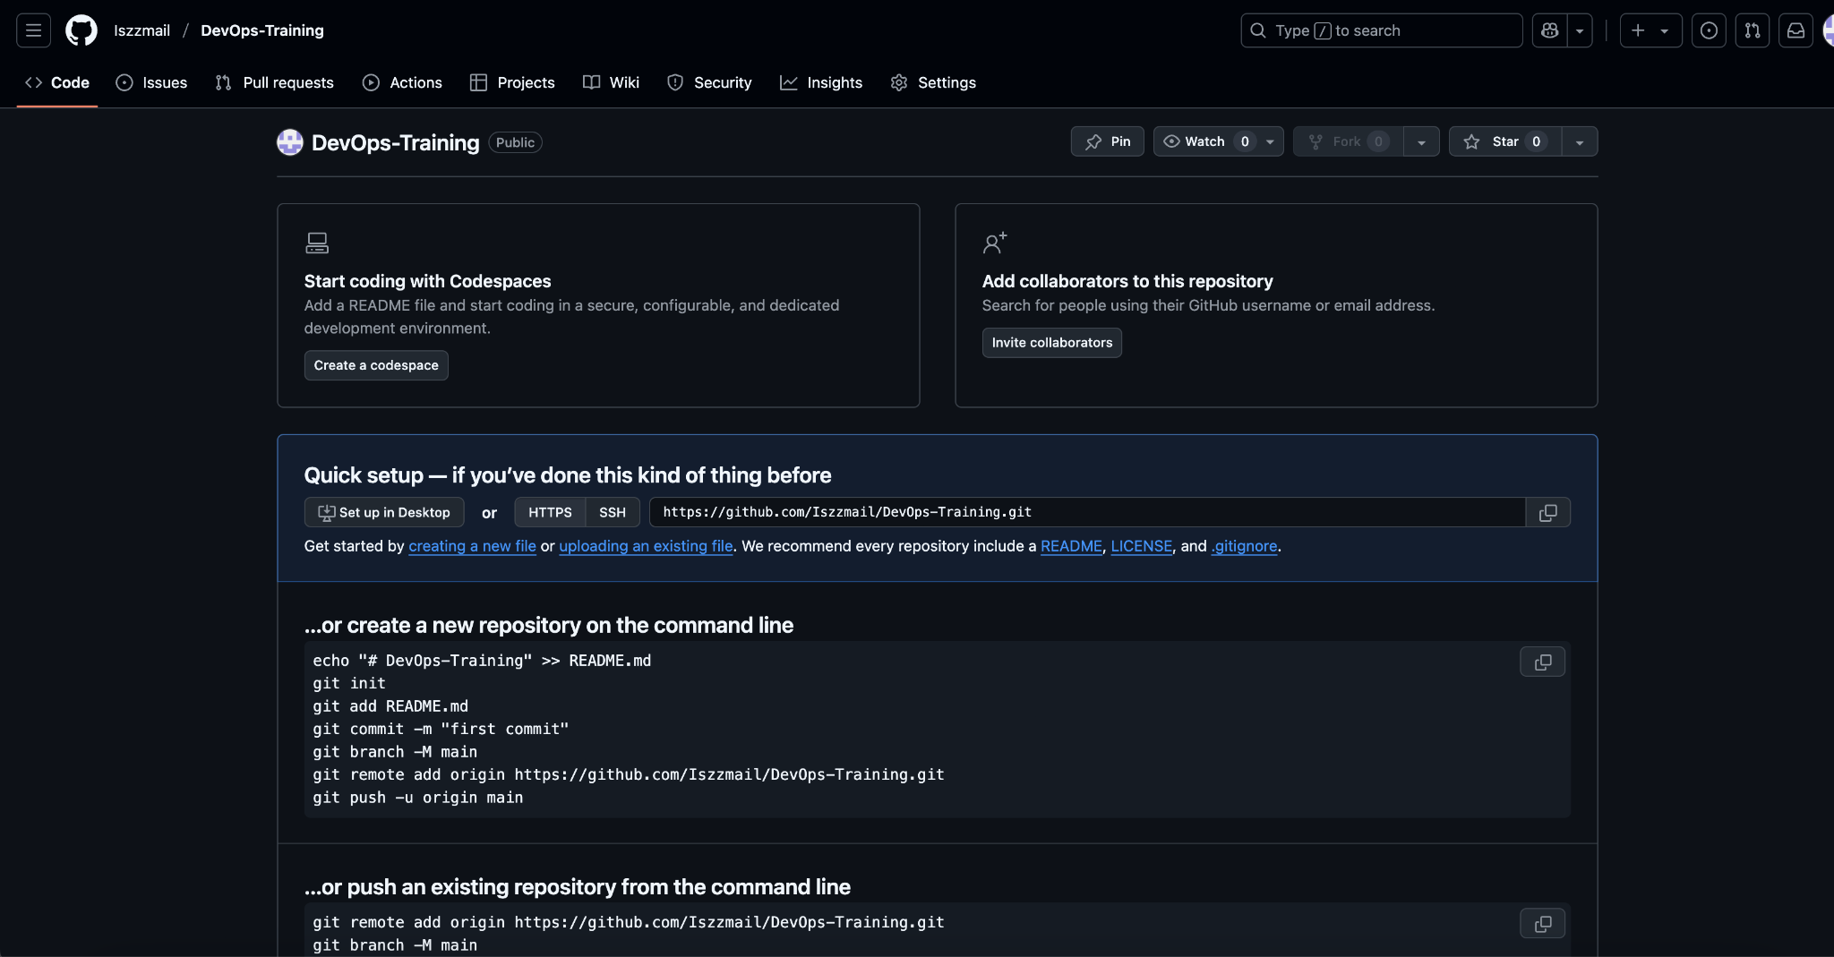

https://github.com/Iszzmail/DevOps-Training